GraphLang – From unordered space to order

Base predictions
Matrix is ordered space representation.
Graph is unordered space representation. Wires between nodes are transformation relationships between nodes.
Data are informations which are floating between nodes, it’s system blood.
Node represent entrance into another space providing input/output ports.
All graph operations can be represend in matrix operations.

All matrices are also graphs
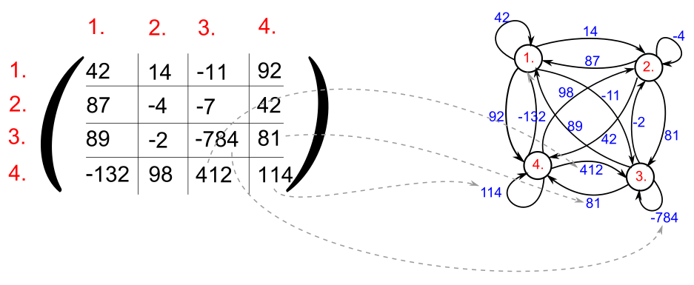

There are no rectangle matrixes all are squares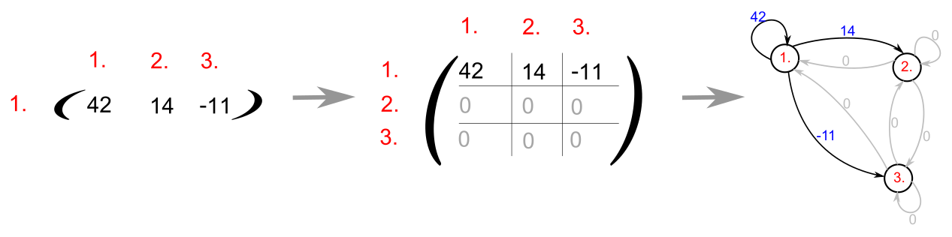

Matrix transpotion in graph
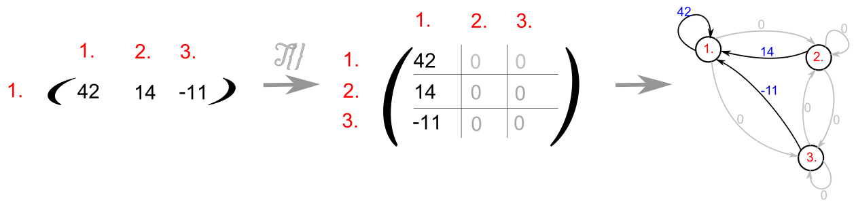

Problem

My Solution

Observation

Conclusion

